**Experiment 7**

**Student Name:** Sahil Kaundal **UID:** 21BCS8197

**Branch:** BE CSE (Lateral Entry) **Section/Group:** 616/A

**Semester:** 5th **Date of Performance:** 04/11/2022

**Subject Name:** ML Lab **Subject Code:** 20CSP-317

1. **Aim/Overview of the practical:**

Implement Decision Tree and compare the performance with Random Forest on any data set.

1. **Task To Be Done:**

Decision Tree and Random Forest. Explained with Python Implementation

1. **Objective:**

To prepare a model with decision Trees and Random Forests Algorithm

**4. Apparatus / Simulator Used:**

1. Windows 7 or above.
2. Google Collab.

**Decision Tree:**

A Decision Tree is a Flow Chart, and can help you make decisions based on previous experience.

**5. Program / Commands:**

#Sahil Kaundal

#21BCS8197

import pandas

df=pandas.read_csv("/data.csv")

print (df)

d={'UK': 0, 'USA': 1, 'N': 2}

df['Nationality']=df['Nationality'].map(d)

d={'YES': 1, 'NO': 0}

df['Go']=df['Go'].map(d)

print(df)

features=['Age', 'Experience', 'Rank', 'Nationality']

X=df[features]

y=df['Go']

print(X)

print(y)

import pandas

from sklearn import tree

from sklearn.tree import DecisionTreeClassifier

import matplotlib.pyplot as plt

df=pandas.read_csv("/data.csv")

d={'UK': 0, 'USA': 1, 'N': 2}

df['Nationality']=df['Nationality'].map(d)

d={'YES': 1, 'NO': 0}

df['Go']=df['Go'].map(d)

features=['Age', 'Experience', 'Rank', 'Nationality']

X=df[features]

y=df['Go']

dtree=DecisionTreeClassifier()

dtree=dtree.fit(X,y)

tree.plot_tree(dtree, feature_names=features)

print(dtree.predict([[40, 10, 7, 1]]))

print(dtree.predict([[40, 10, 6, 1]]))

1. **Result/Output/Writing Summary:**

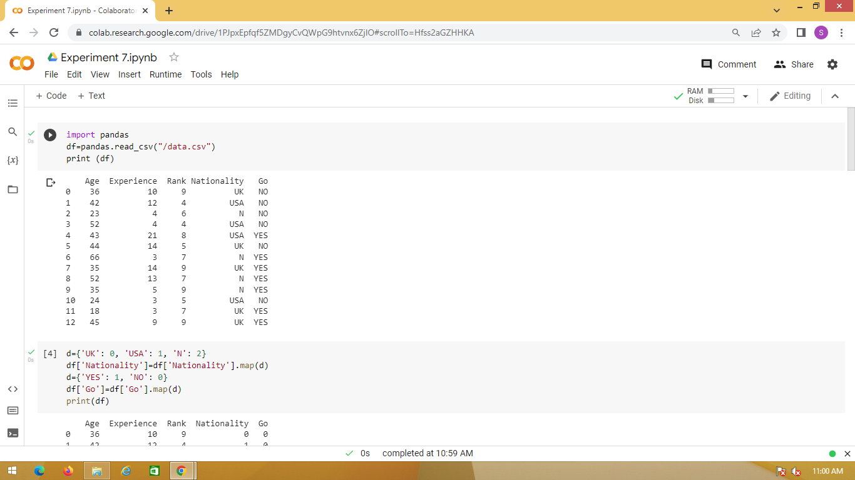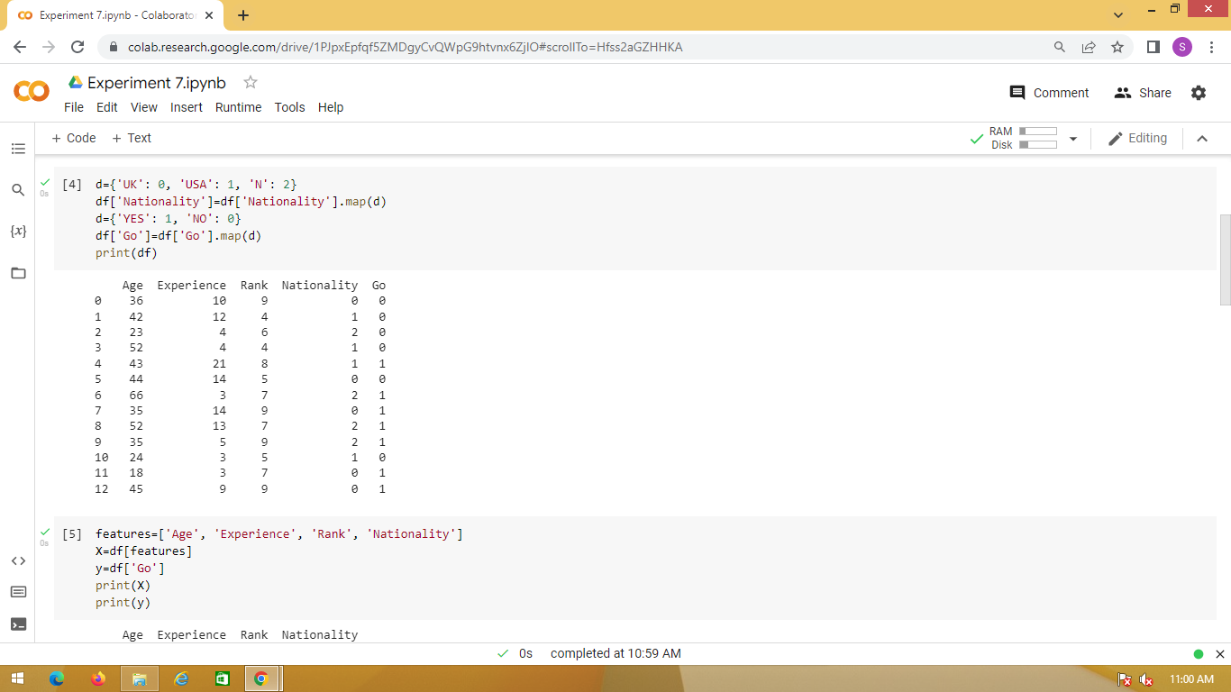

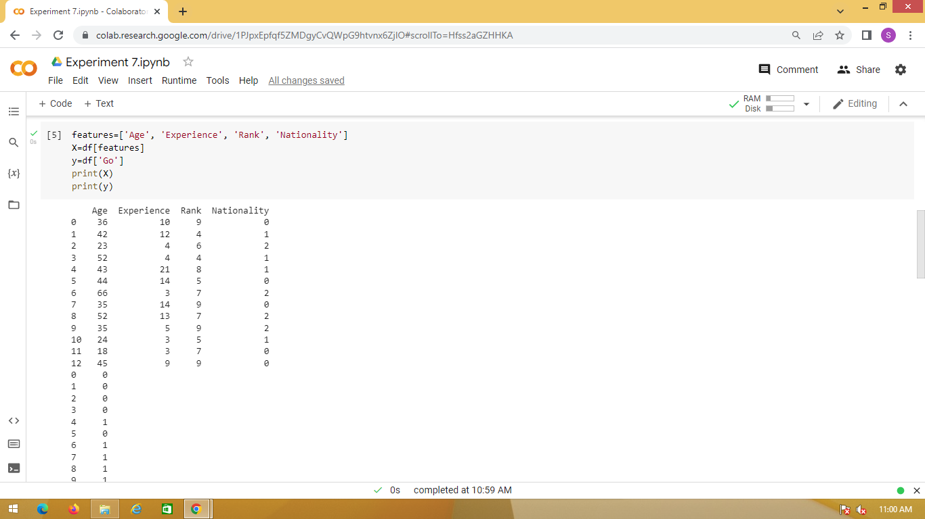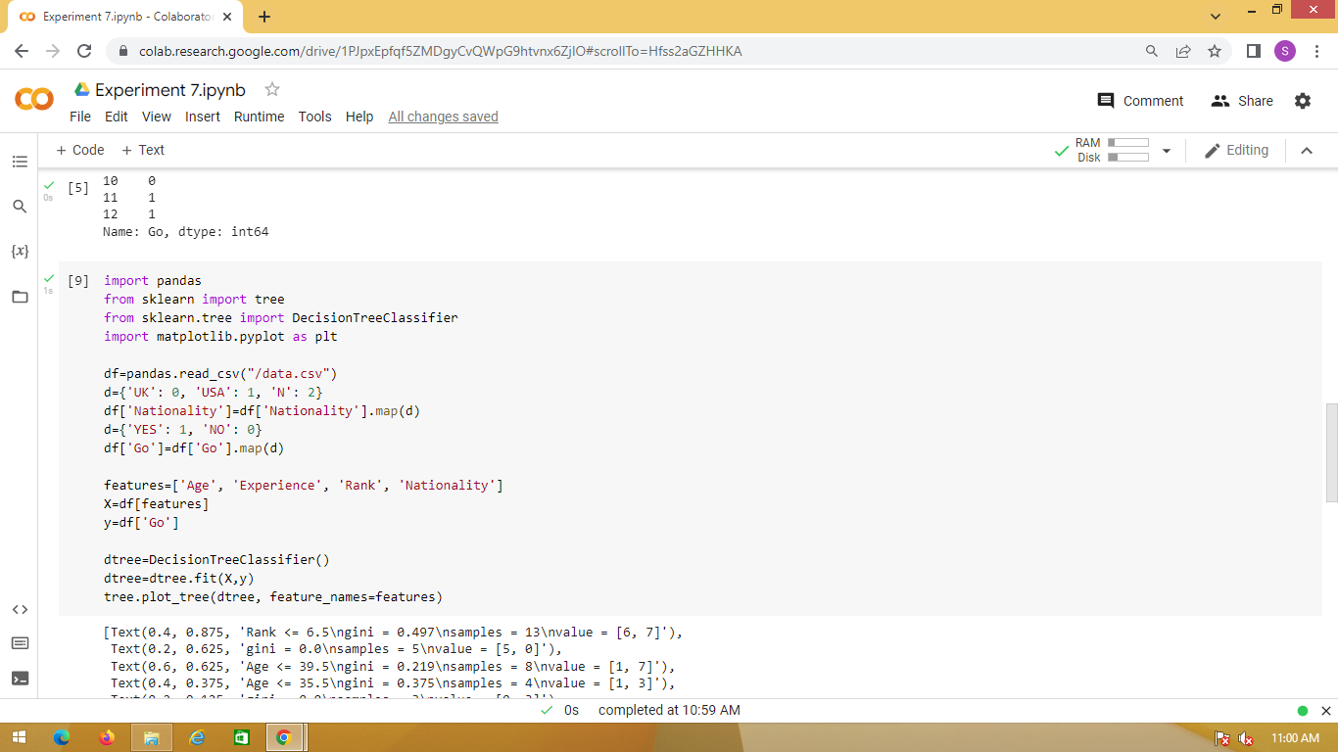

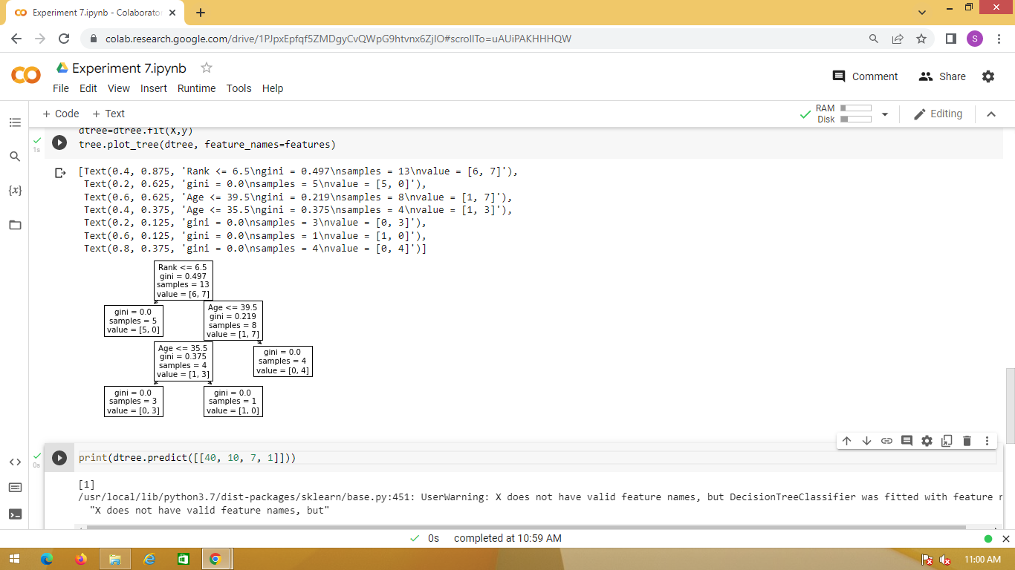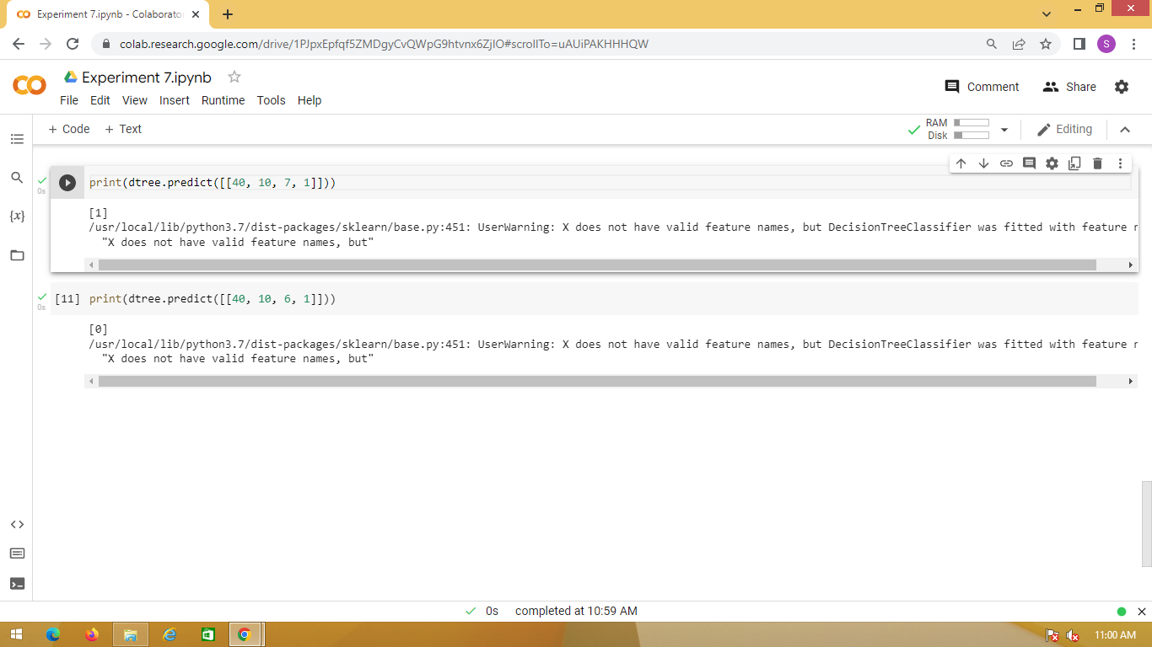

**Learning outcomes (What I have learnt):**

* Understood the concept of Decision Tree.
* Learnt how to load the dataset and map it.
* Printing the data according to the feature available in the dataset.
* Plot the Decision Tree and predict it.

**Evaluation Grid (To be created as per the SOP and Assessment guidelines by the faculty):**

|  |  |  |  |
| --- | --- | --- | --- |
| Sr. No. | Parameters | Marks Obtained | Maximum Marks |
| 1. |  |  |  |
| 2. |  |  |  |
| 3. |  |  |  |
|  |  |  |  |